Wohlenberg 10mm hinge spacer set
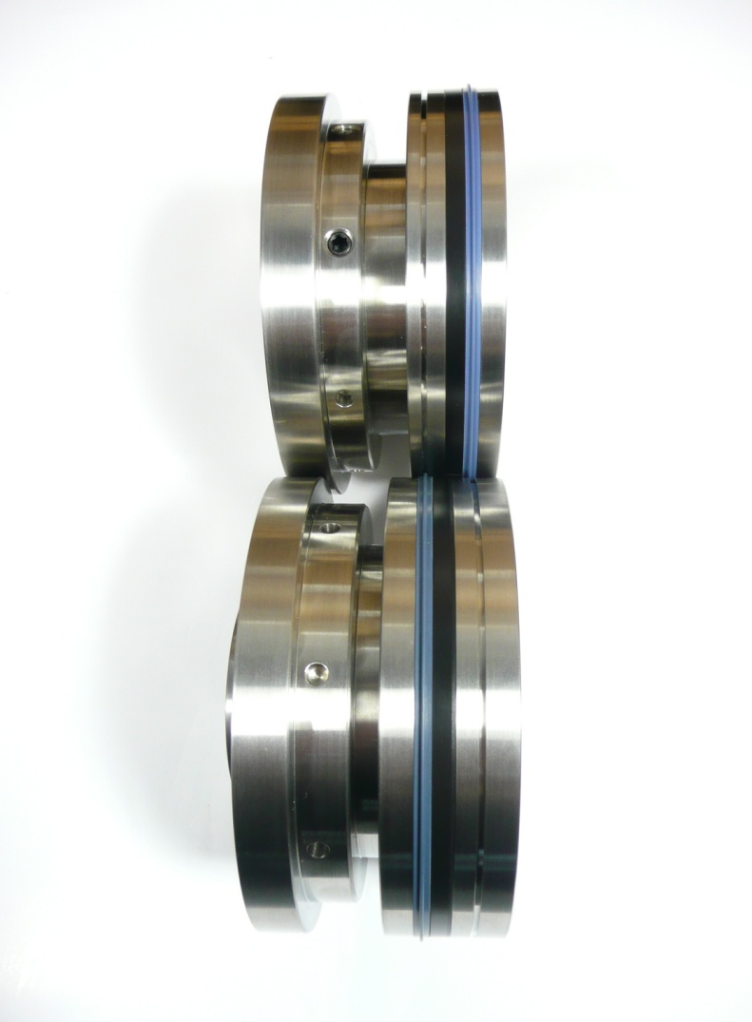
A The top shaft crease unit

B The bottom shaft crease unit
A

B

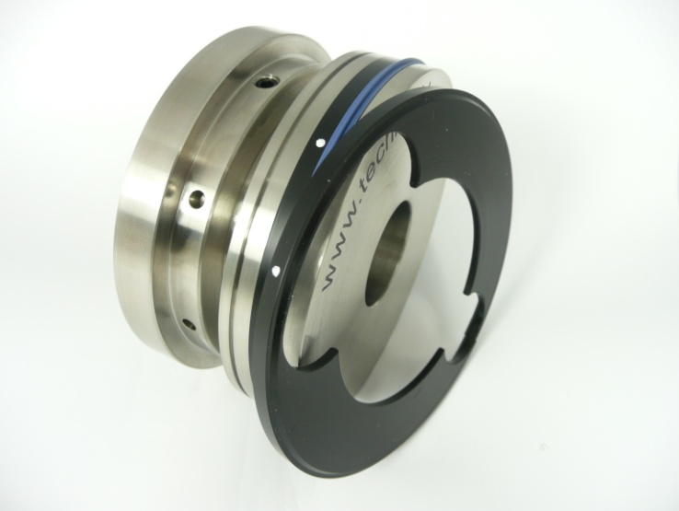
TOP SHAFT A
Unscrew the crease rib holder as far as possible and Insert the black spacer into the gap.
Place the spacer with the ends facing the correct way as the shaped metalwork on the holder

A

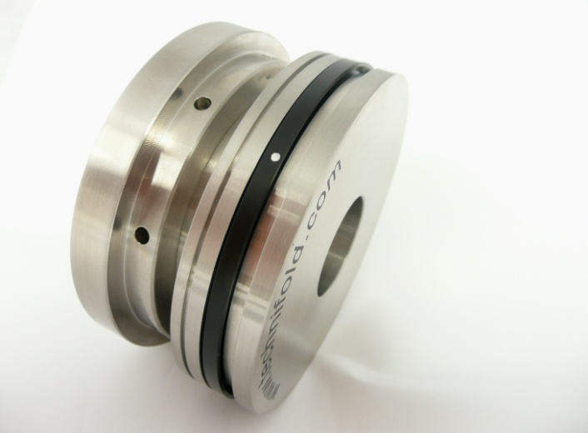

The 10mm hinge spacer fitted into the rib holder.

A

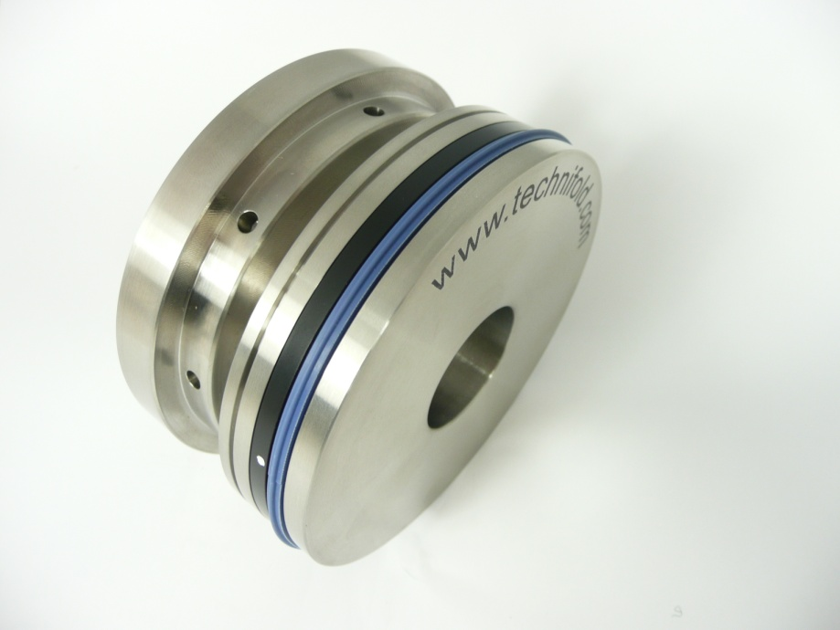

The spacer and crease rib in the correct position

A

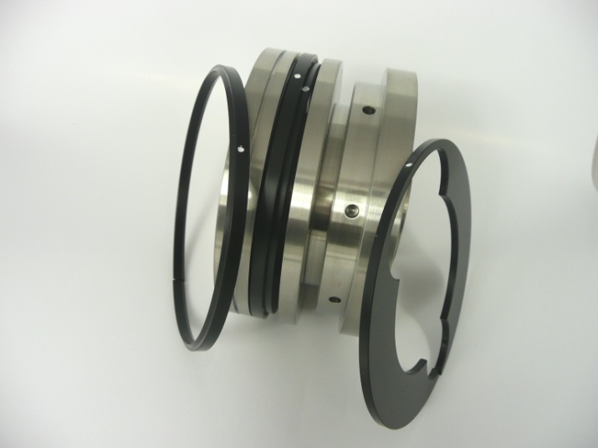
Bottom Shaft B
B

Bottom Shaft B
2 x spacers are required on the bottom shaft.

2
1

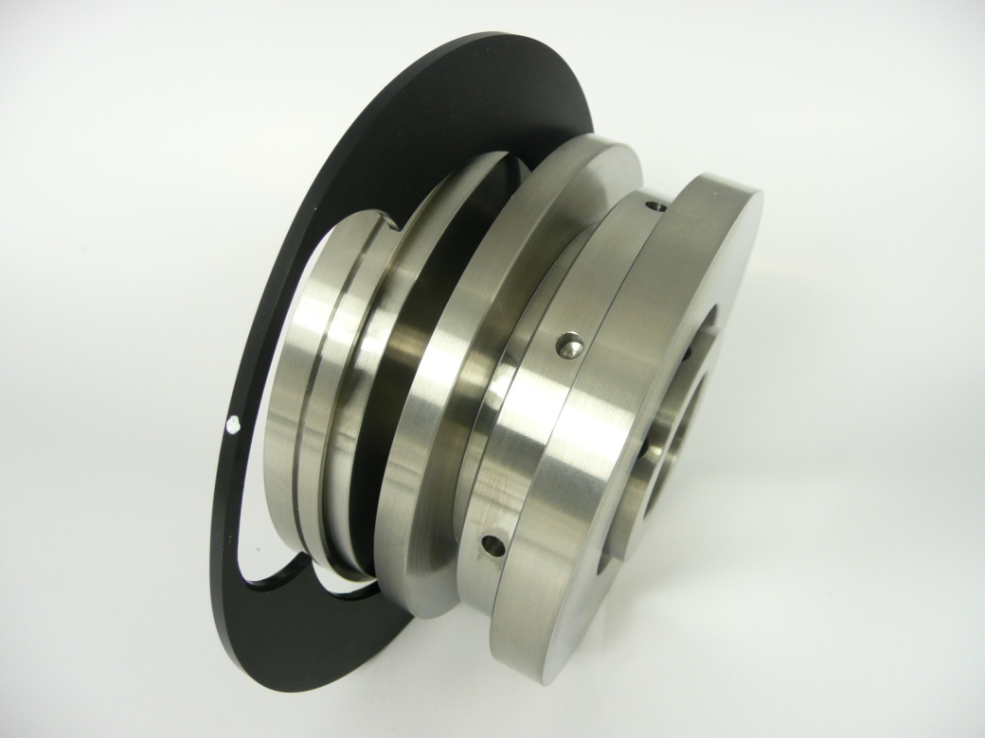
Place No 1 spacer onto the screw thread in the opening

1

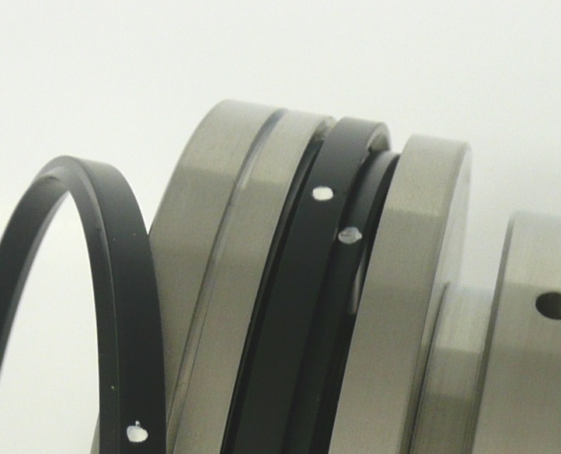

Make sure the shape on the black nylon insert matches the shape in the holder.

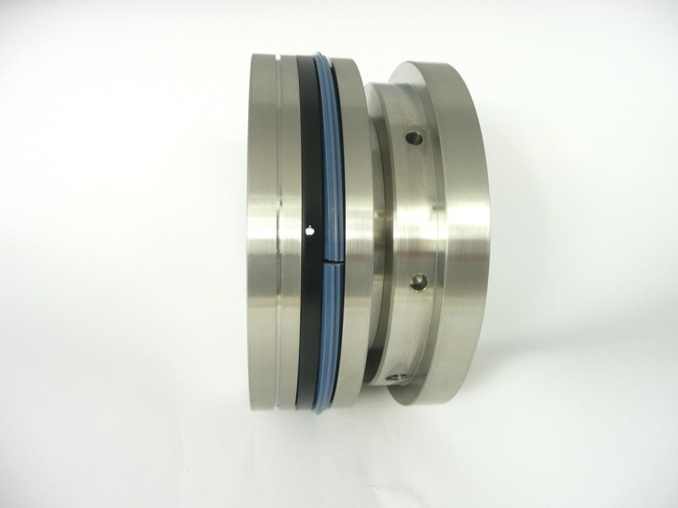
The 2 spacers and the crease rib ready to be screw tightened together

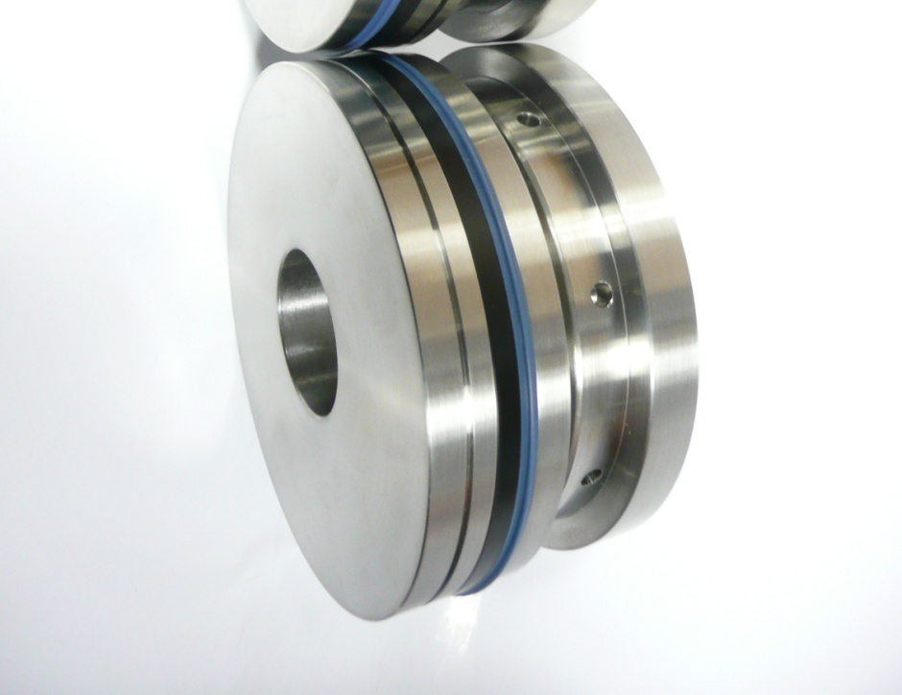
B
Bottom shaft holder with the spacers and rubber crease ribs ready to use.

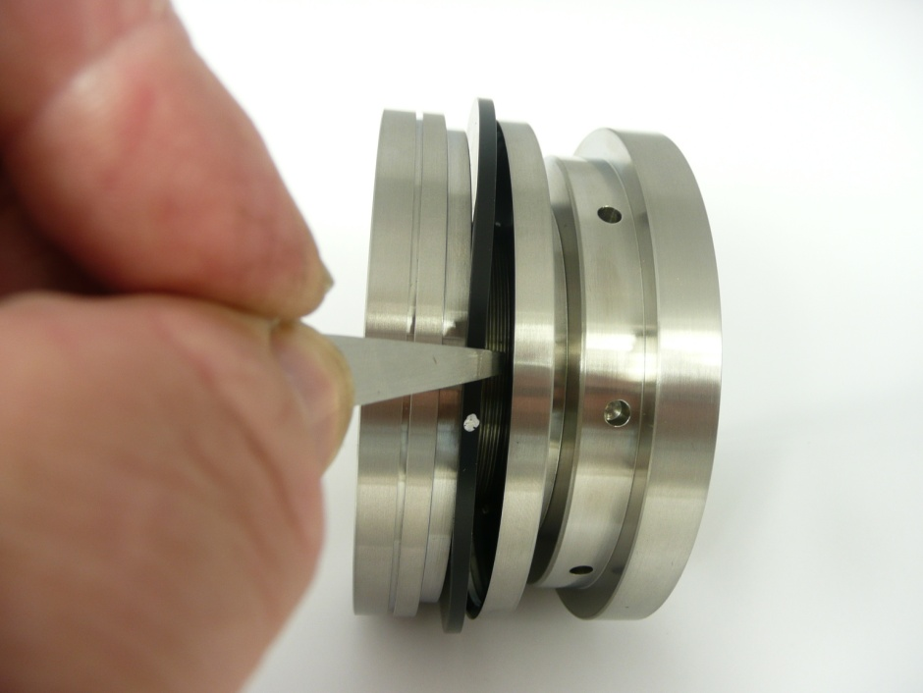
Removing the black nylon spacers
The white dot indicates the correct removal position to the pull out the black inserts.

Use the small plier tool that comes with the spacer pack to grip and remove the black nylon spacers.

